SQL CODING CHALLENGE

1.Database Creation

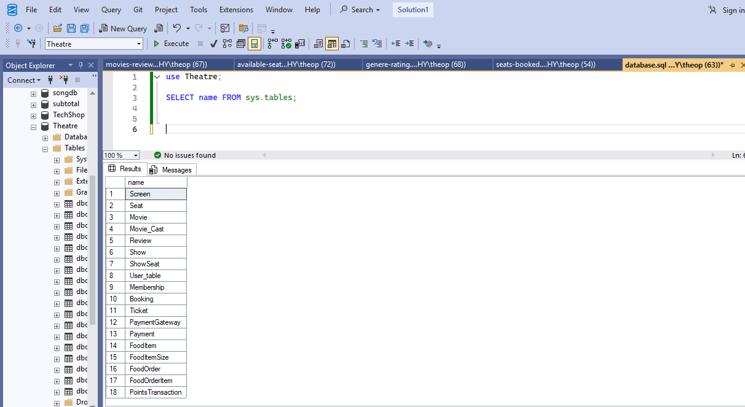

2.Joins with Aggregate functions, WHERE,GROUP BY,HAVING, ORDER BY Questions with Answers

1.Number of seats booked.

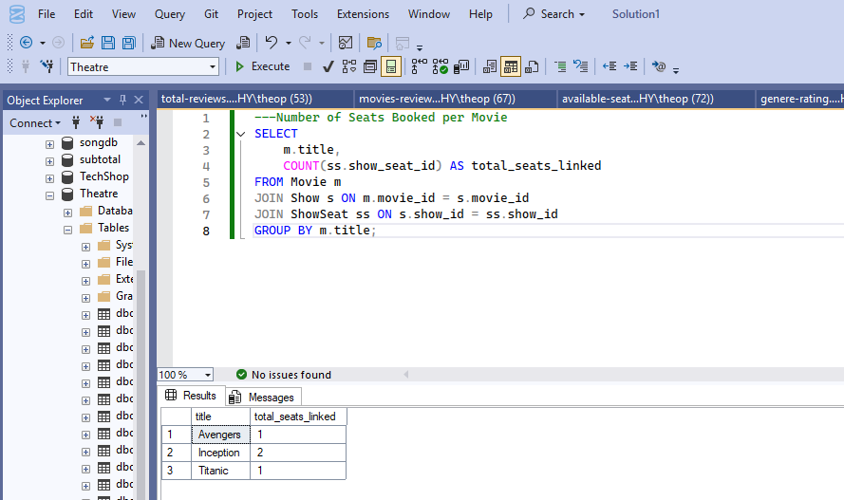

2.Total reviews

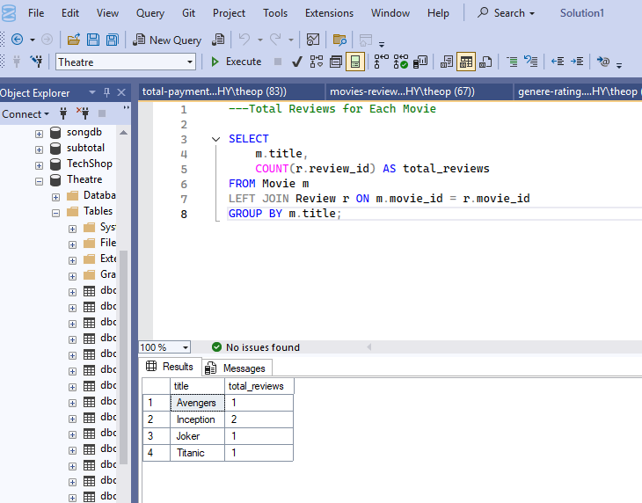

3.Number of seats Booked

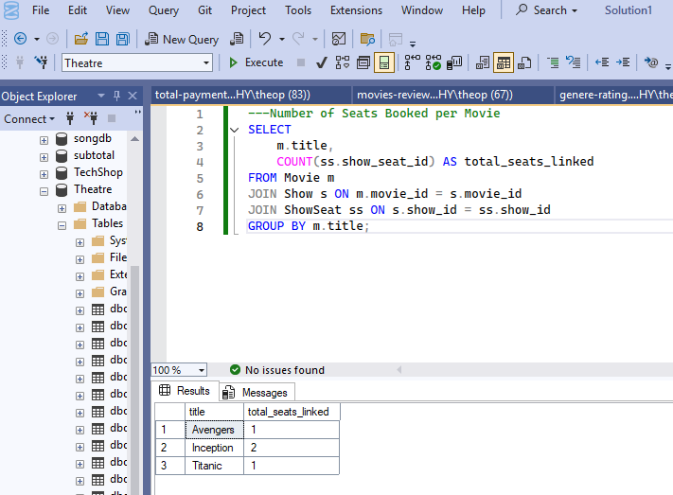

4.Genre Rating

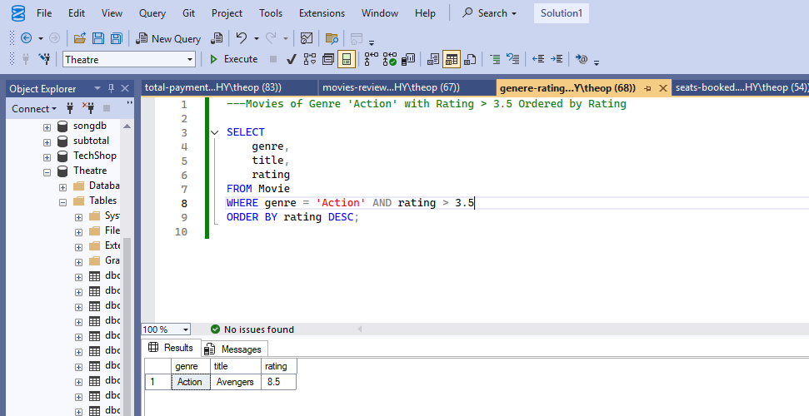

5.Movies review more than 1

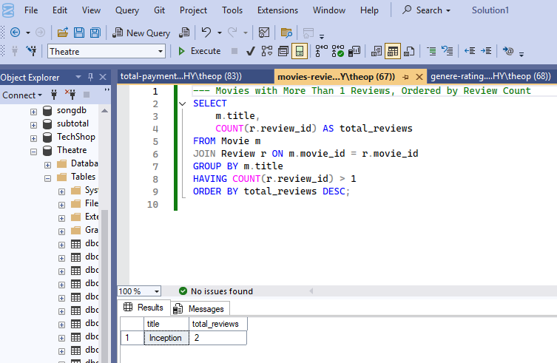

6.Total Payment collected via each gateway

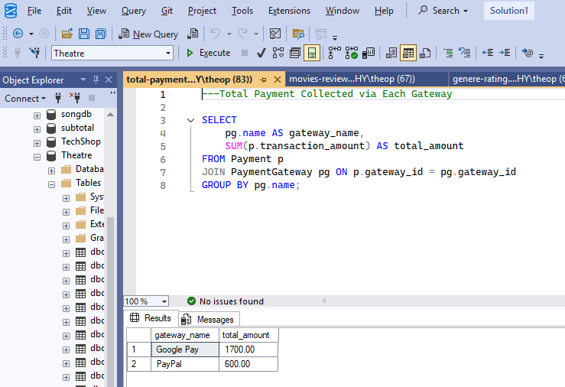

7.Available seats

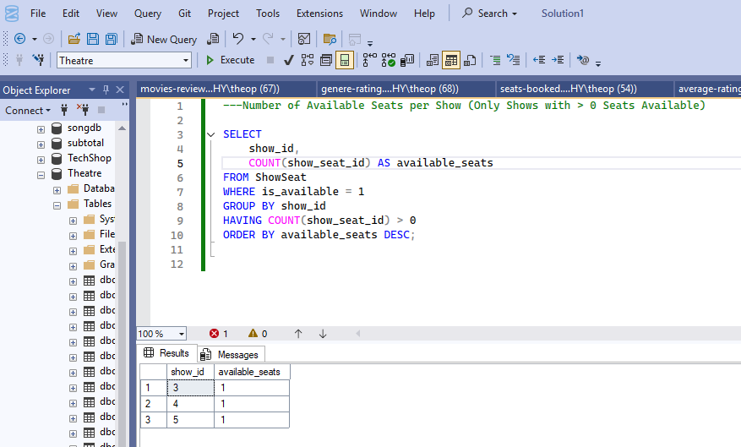

8.Average rating

